Chdimma Ibeh

Object-Oriented Programming

6/28/2019

**Software Architecture Document**

1. **Introduction**
   1. Purpose

This document provides an architecture overview of the Library Management System.

* 1. Scope

This Software Architecture Document an overview of the Library Management System

* 1. Definitions, Acronyms, Abbreviations

See the Glossary

* 1. References

**2. Architectural Representation**

This document presents the architecture as a series of views, use case view, logical view, process

view, and deployment view. The views are based on Unified Modeling Language (UNL).

**3. Architectural Goals and Constraints**

1. All users must have access to the Library Management Systems on local library PC and a remote PC. All username and password are required to log in to the system.
2. The Library Management System must ensure complete protection from unauthorized users.
3. The Library Management System is implemented as a client-server. The client side runs on a PC, and the server side run on a local library server.
4. The existing legacy Library Catalog System at the local library must be accessed to retrieve current library book availability.
5. The Library Management System must support legacy Library Catalog System.
6. All loading and performance requirements are listed in the Library Specification Document.

**4. Use-Case View**

A description of the use-case view of the software architecture. This use case view describes the set of scenarios and central functionality.

The Library Management System:

-Login

- Find Balance

-Make a Payment

- Borrow Book

-Renew Book

-Get Library Balance

-Charge a Fine

-Order Book

-Add New Book

-Replace Book

4.1 Architecturally Significant Use Cases

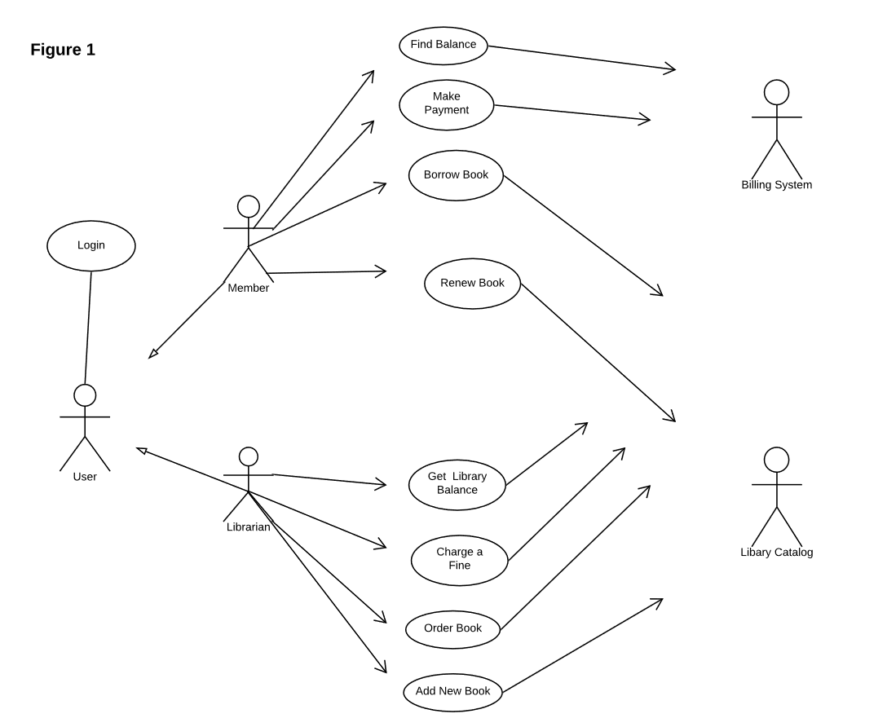

Diagram Name Architecturally Significant Use-Cases

4.1.1 Login

Brief Description: This use case describes how a user logs into the Library Management System. The actors are Members and Librarians.

4.1.2 Find Balance

Brief Description: This use case describes how a member can look up their balance. The actor is the member.

4.1.3 Make Payment

Brief Description: This use case describes how a member can pay their balance. The actor is the member.

4.1.4 Borrow Book

Brief Description: This use case describes how a member can borrow a book. A member can borrow up to 50 books at a time. The actor is the member.

4.1.5 Renew Book

Brief Description: This use case describes how a member can renew a book. The actor is the member.

4.1.6 Get Library Balance

Brief Description: This use case describes how a Librarian can check the library balance. The actor is the Librarian.

4.1.7 Charge Fine

Brief Description: This use case describes how a Librarian can charge a member a fine for overdue or missing book. The actor is the Librarian.

4.1.8 Order Book

Brief Description: This use case describes how a Librarian orders a book and replace a book. The actor is the Librarian.

4.1.9 Add New Book

Brief Description: This use case describes how Librarian adds a new book to the Library catalog. The actor is the Librarian.

**5. Logical View**

A description of the logical view of the architecture. This describes the classes. Class diagram is included to illustrate the relationships between the architecturally classes. The logical view of the library management system is comprised of three packages: User Interface, Business Services, and Business Objects.

The User Interface Package are the User, Member, and Library classes. These classes are the forms that the actors use to communicate with the System. These classes exist to support login, maintaining of book availability, maintaining of member’s info, selecting books, and maintaining librarian’s info.

The Business Services Package contains control classes for interfacing with the billing system and managing book inventory.

The Business Objects Package is the book class. These classes are the interface for the library Catalog System.

5.1 Architecture Overview – Package and Subsystem Layering

5.1.1 Application

This application layer has all the classes that represent the application screens that the user sees.

5.1.2 Business Services

The Business Services layer is the controller.

5.1.3 Middleware

The Middleware layer supports access to the database.

5.1.4 Base Reuse

**6. Process View**

A description of the process view of the architecture. The Process Model illustrates the library management system classes organized as executable processes. Processes exist to support library catalog, management, librarian functions, book management closing, and access to the external Billing System and Library Catalog.

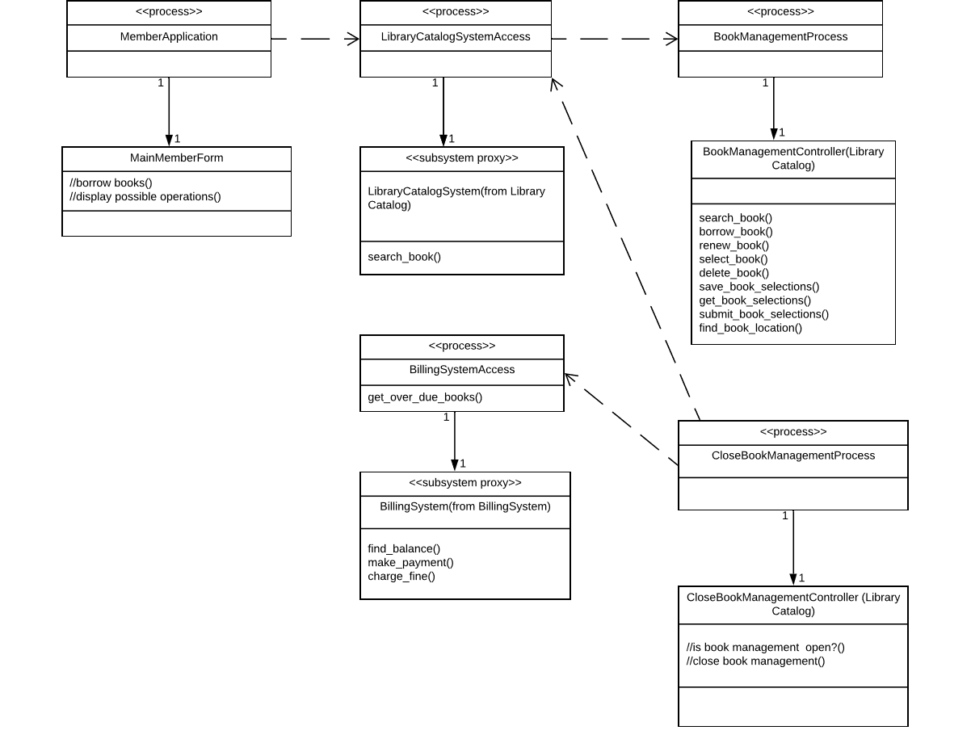

Diagram Name Processes

* + 1. LibraryCatalogSystemAccess

This process manages access to the legacy Library Catalog System. It can be shared by multiple users borrowing books.

Analysis Mechanisms:

-Legacy Interface

Requirements Traceability:

-Design Constraints: The system should integrate with existing legacy system (library catalog database)

6.1.2 Library Catalog

The catalog of all books and book selections offered by the library.

* + 1. BookManagementProcess

There is one instance of this process for each member that is currently selecting books.

* + 1. BookManagementController

This support the use case of allowing members to search and borrow books. The member can modify and delete their book selections.

* + 1. MemberApplication

Manages the member functionality, including user interface processing and coordination with the business processes.

There is one instance of this process for each student that is borrowing and renewing books.

* + 1. MainMemberForm

Controls the interface of the Member application.

* + 1. BillingSystemAccess

This process communicates with the external Billing System to initiate member billing.

* + 1. CloseBookManagementProcess

The Close Book Management process is initiated at the end of the book management process. This process communicates with the process controlling access to the Billing System.

* + 1. BillingSystem

The Billing System supports the submitting of member’s bills for overdue and unreturned books.

* + 1. CloseBookManagementController

The Close Book Management Controller controls access to the Billing System.

* 1. Process to Design Elements

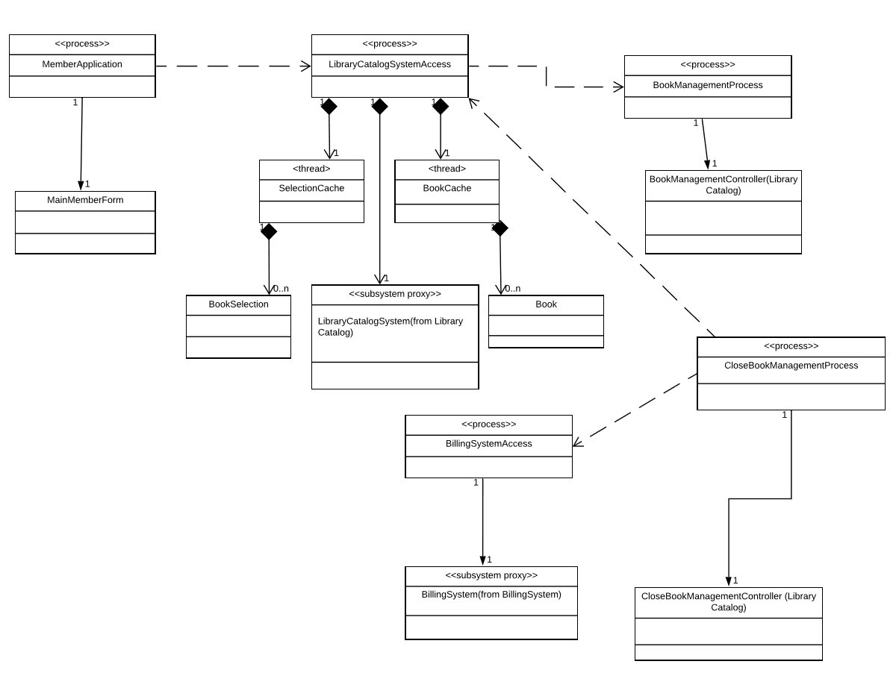

6.2.1 BookCache

The Book Cache thread is used to retrieve items from the legacy Library Catalog System.

6.2.2 SelectionCache

The Selection Cache thread is used to retrieve items from the legacy Library Catalog System.

* + 1. Book

A class offered by the university.

Analysis Mechanisms:

-Persistency

-Legacy Interface

* + 1. BookSelection

A specific selection for a book includes book availability.

Analysis Mechanisms:

-Persistency

-Legacy Interface

* 1. Process Model to Design Model Dependencies

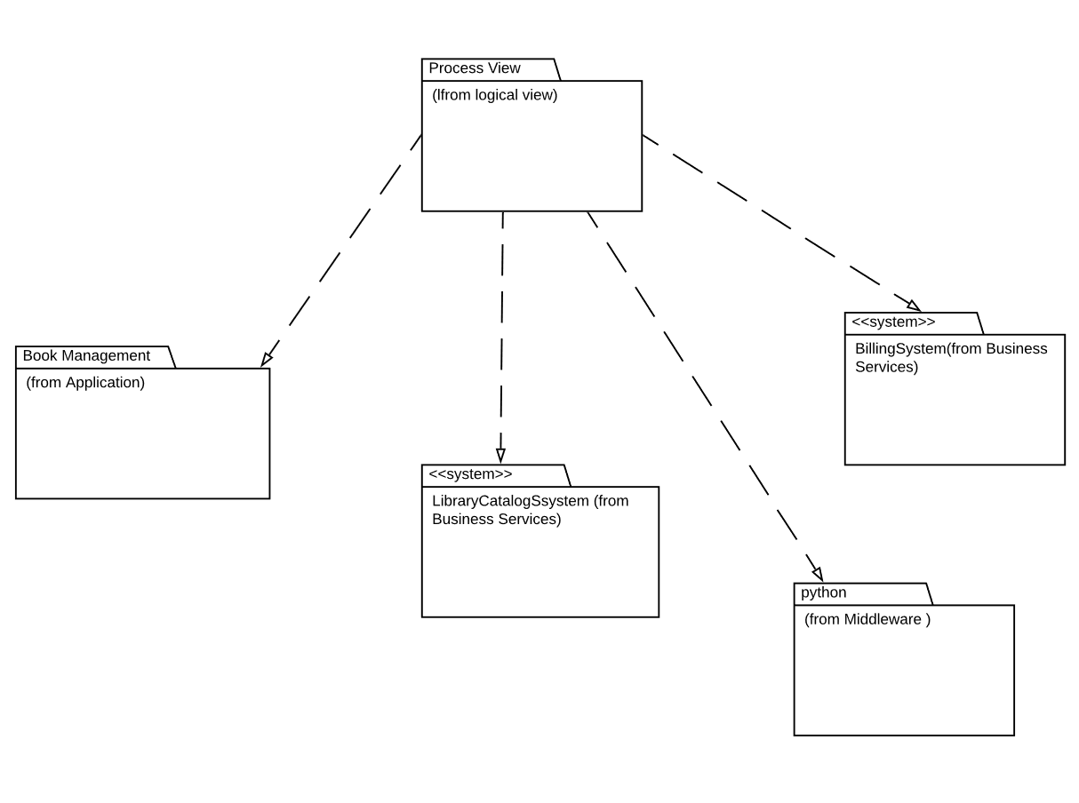

Diagram Name: Process Model to Design Model Dependencies

* 1. Processes to Implementation

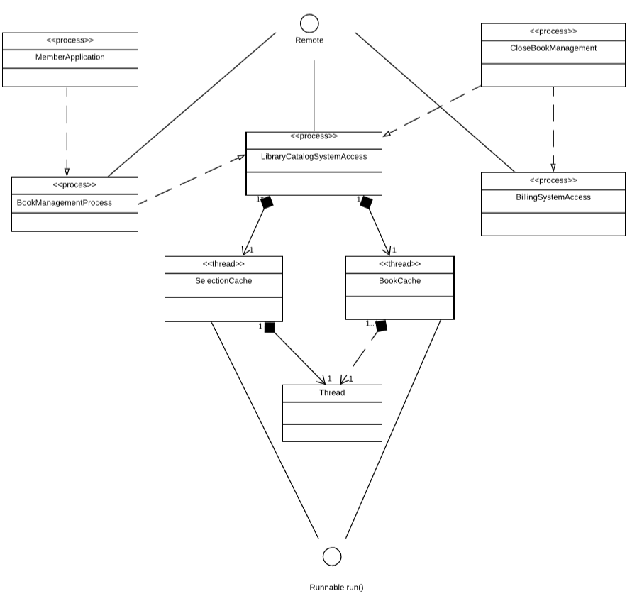

6.4.1 Remote

The Remote interface serves to identify all remote objects. Any object that is a remote object must directly or indirectly implement this interface.

6.4.2 Runnable

The Runnable interface should be implemented by any class whose instances are intended to be executed by a thread. The class must define a method of no arguments called run.

* + 1. Thread

A thread is a thread of execution in a program

1. **Deployment View**

A description of the deployment view of the architecture. It describes the various physical nodes for the most typical platform configurations. It describes the allocation of tasks (from the Process View) to the physical nodes.

This section is organized by physical network configuration.

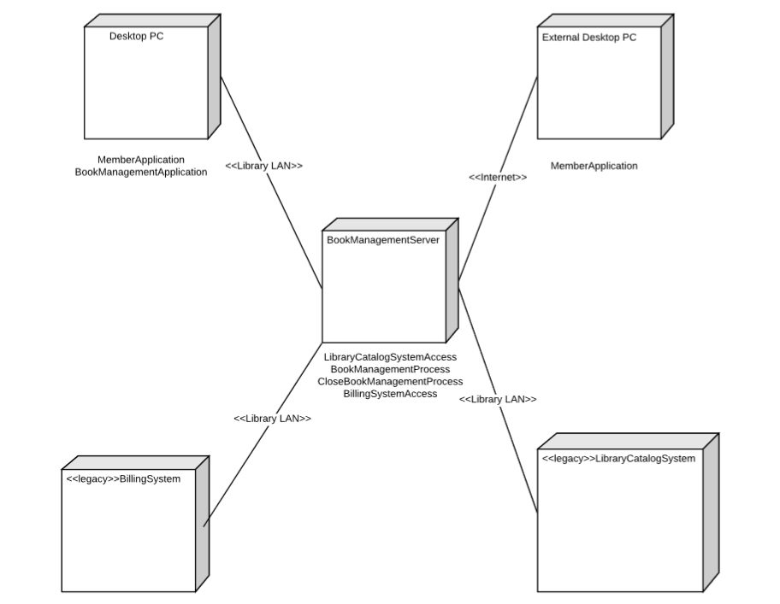

Diagram Name: Deployment View

* 1. External Desktop PC

Members borrow and renew books using external desktop PCs which are connected to the Library Server via internet.

* 1. Desktop PC

Members borrow and renew books via local Desktop PC’s that are connected directly to the Library Server via LAN. The local PC’s are used by the librarians to manage the books and finances of the library. The staff in charge of the book management

* 1. Book Management Server

The Library Server is the UNIX server. All members and Librarians have access to the Server through the Library LAN.

* 1. Library Catalog System is a legacy system that contain the complete library catalog. Access to it is available via the Library Server and LAN.
  2. Billing System

It is a legacy system that generates member’s bills.

1. **Size and Performance**

The software architecture supports the key sizing and timing requirement.

1. The software shall support 1500 users against the central database at any given time, and up to 500 users against the local server.
2. The system shall provide access to the library catalog with no more than 12 second latency.
3. The system must be able to complete 85% of all transactions within 3 minutes.
4. **Quality**

The software architecture supports the quality requirements.

1. The Library Management System shall be available 24 hours a day, 7 days a week.
2. The Library Management System shall have built-in online help for the user. Online help shall include step by step instructions and definitions or terms.
3. Downloadable upgrades from the UJIX Server over the internet shall be available to the PC client of Library Management System.
4. The user interface of the Library Management shall be designed for ease-of use and local library can provide additional training.